CPT 208 Group Project

Coursework/Assignment Submission Form

2020/21 Semester 2

Bachelor’s degree – Year 3

|  |  |  |
| --- | --- | --- |
| Module Code | Module Leader | Module Title |
| **CPT208** | **Lingyun Yu** | **Human-Centric Computing** |

**Section A: Your Details**

*To be completed by the students (in English using BLOCK CAPITALS)*

|  |  |
| --- | --- |
| Student ID | Name |
|  |  |
|  |  |
|  |  |
|  |  |
|  |  |

**Section B: Assignment Details**

*To be completed by the students (in English using BLOCK CAPITALS)*

|  |  |
| --- | --- |
| Coursework Assignment Number | **Group report (Evaluation)** |
| Coursework (assignment) Title |  |
| Method of Working | **Group** |
| Date and time of submission |  |

*Assignment details can be found in the assignment description.*

**Section C: Statement of Academic Honesty**

*To be completed by the students*

By submitting this coursework for assessment, you are confirming that you have read and understood the University’s policy on plagiarism and collusion and that the submitted work is your own.

1. We confirm that we have read a copy of the current University’s definitions of collusion and plagiarism on coursework and academic honesty, and that we fully understand the meaning of these terms.
2. We confirm that the submitted coursework has been created solely by our group and that we have not been assisted, nor have copied part or all of somebody else’s work, either with their explicit approval or without their knowledge or consent.
3. We confirm that this is our own work and that use of material from other sources, including the Internet, has been properly and fully acknowledged and referenced.
4. We confirm that the information we have given is correct to the best of our knowledge.

|  |  |  |  |
| --- | --- | --- | --- |
| Student’s signature |  | Date |  |

*If this form is submitted electronically, please type your name in English (BLOCK CAPTIALS)*

Report Title

Introduction (15 points)

In this section, you will introduce the environment where the products / applications are being used and in which context.

Learning Mall is an online assist course website that developed by XJTLU, which can supply a wide range of learning materials and didactical supports for students. There are two functions: login function and jump button.

User Evaluation (25 points)

Observation of people who use them and discuss how people use them, what they expect and what they get, interviews (in case you need).

Lots of LM-users may close and re-entry LM after once login. When users re-entry, LM still in Home page, and still shows a “log in” button as below



However, it will show “You are already logged in” when user click “log in” button to login.

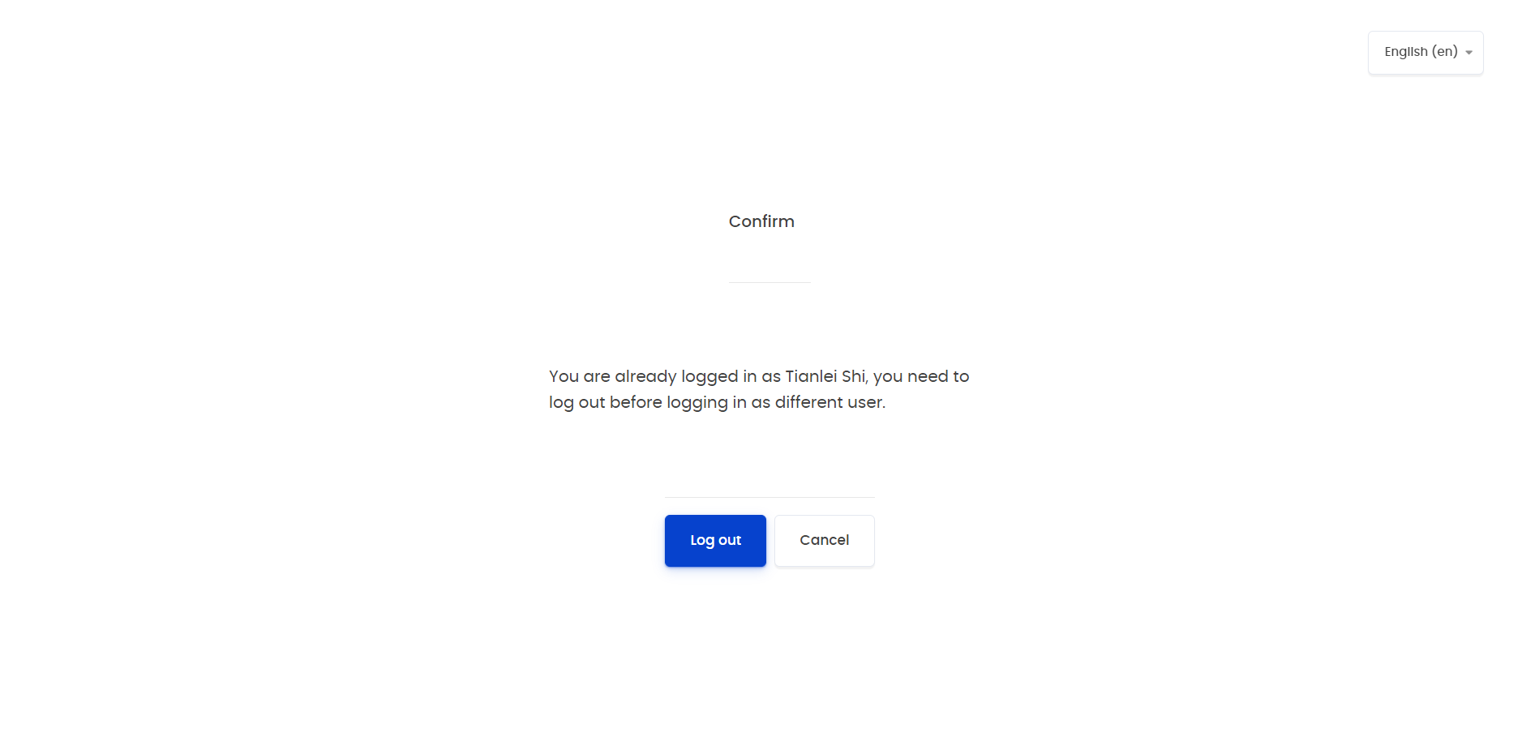

This makes users really confused, and they may click “log out” button and re-login. But the correct way is to click the blue button in upper-right, find “Dashboard” button, and click it.



A lot of students don’t know there a blue button, and this function make many inconvenient for users.

Moreover, students usually use jump button to make LM jump to other modules. But some jump button is an imaginary button. Such as the “my course” button.

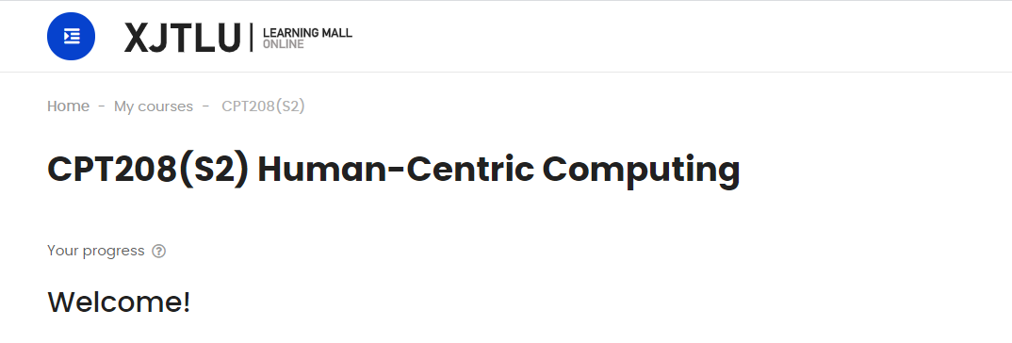

This button cannot be click, and cannot jump to other modules. This make users so unexpected, because this is an inside path, if this path not exist, the following path should not exist either.

Discussion (40 points)

Discuss which design principles are violated, explain the design principles and give references.

It is a well-known specification that the opposite of log in should be log out, users also agree with that. However, it still shows “log in” button when users logged in, it will make users confuse. So, the design principle of “Let the User Develop a Mental Model” is the first DP be violated. Nevertheless, if users want to start learning, they must click the blue button lying on upper-right, find “Dashboard” button, and click it. Which is super inconvenient! LM should show the best important information to users instead of showing beauty but not useful pictures and hide key button. Thus, “Simple and Natural Dialog" is the second DP that be violated.

What’s more, the imaginary button is obviously violating the design principle of “Simple and Natural Dialog, Let the User Develop a Mental Model”. Because it’s a common sense that “a button should be work, especially it is a path (since everywhere in path is place that I had been traveled). However, now this common sense is broken by this “my course” button, and this button is useless and delete-ok additionally.

Conclusion (20 points)

Discuss how to improve the designs.

For the login function, firstly, webpage should hide the “log in” button if users had been logged, which will avoid confusion effectively. Secondly, according to the statistical results, around 70% users think LM should jump to dashboard directly, and around 30% users advised that LM should move the “Dashboard” button to a more obvious place.

Moreover, for the “my course” problem, 50% students think such buttons should be deleted, and 20% people discuss that LM should use a real path instead of an imaginary button.

Reference:

[1]